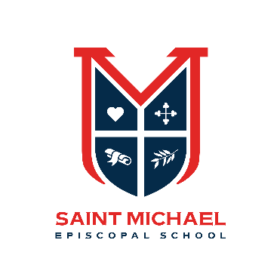
Uniform Guidelines
All students enrolled in a PreK or Kindergarten class wear uniforms to school every day. We ask that you please read through these guidelines carefully so that all are informed as to the details of these policies.
Uniforms may be purchased through Risse Brothers School Uniforms. You may order and purchase in person at the Risse Brothers location in Dallas. Beginning mid-May 2023, online orders may also be placed at www.rissebrothers.com. Risse Brothers provides 10% of all sales for the year back to our school.
Risse Brothers will hold a one-week online sale just for SMES families June 12-17. During this week, all items are 10% off, in-store only. See the flyer for more details.
The school strongly encourages parents to label all appropriate uniform items to aid us in returning lost items.
Logos of any kind (Polo, Under Armour, etc.) including tags and labels are not permitted on any area of the uniform.
Girls
- Dress - Navy/white hounds tooth button-up dress with Peter Pan collar. Collar will come with an SMES monogram.
Modesty shorts (navy blue or white) should be worn under the dress.
- Jumper - Navy/white hounds tooth jumper.
- Skort - Navy/white hounds tooth skort.
- Top - Red pique knit polo shirt or white Peter Pan collar blouse. Short or long sleeves are permitted.
- Shorts/Pants - Navy blue Bermuda-length twill shorts or trousers with elastic waistband. Cargo shorts or other styles are not permitted. Shorts and pants may be purchased at stores other than Risse Brothers, but please note the quality and durability of their product. Belts are not permitted.
- Shoes - Solid white Velcro tennis shoes. Keds or other solid white, navy or red sneakers.
- Socks - Plain white bobby socks or knee socks. Low athletic socks are not permitted. Beads, ribbon, lace, etc. are not permitted.
- Sweater - Optional navy blue, red or white plain knit cardigan sweater. Sweaters may be personalized with a simple name or monogram. School embroidered sweaters will also be available from Risse Brothers uniforms.
- Coats and outerwear are NOT part of the school uniform and may be of your choosing.
Boys
- Shorts/Pants - Navy blue Bermuda-length twill or hounds tooth shorts or trousers with elastic waistband. Cargo shorts or other styles are not permitted. Shorts and pants may be purchased at stores other than Risse Brothers, but please note the quality and durability of their product. Belts are not permitted.
- Shirt - Red or gray cotton pique knit polo shirt. Short or long sleeves are permitted. We ask that every family purchase at least one shirt with the embroidered school crest.
- Shoes - Solid black or navy Velcro tennis shoes – may have white trim.
- Socks - Plain, no logo, white crew socks. Low athletic socks are not permitted.
- Sweater - Optional navy blue, red or white plain knit cardigan sweater. Sweaters may be personalized with a simple name or monogram. School embroidered sweaters will also be available from Risse Brothers uniforms.
- Coats and outerwear are NOT part of the school uniform and may be of your choosing.
Accessories
- No jewelry is allowed except for small stud earrings or a religious necklace.
- Girls may wear navy blue, red or white hair bows or headbands. Bows may be personalized or monogrammed.
- Girls may wear red, navy blue or white leggings or tights during colder weather months.

Spirit and Free Dress Days
- On designated Spirit days, children may wear the SMES cotton or SMES Nike t-shirts. These shirts will be available for purchase August 2023 at Saint Michael Episcopal School.
- Occasionally SMES will have free dress days and advanced notice will be communicated.

